Standards in writing a paper proof

**When a paper proof is ready, you need to**

1. Answer “Author Queries” correctly and properly, and label them in the manuscript pdf file;
2. Proofread the manuscript carefully, and mark the corrections we want to make. Please note that errors and typos may be introduced in the manuscript by the editor.

**When you want to label corrections in the manuscript pdf file, please make sure you use the standard operations.**

1. Make sure you use “Comment” (as shown in the figure below) instead of “Edit”. The “Comment” command can be found in “Edit”—“Edit text and images”—“Comment”.



1. Please use standard commands to show the corrections you want to make.

If you want to delete something, please use .

If you want to add something, please use .

If you want to replace something, please use .

If you want to add a comment, please use .

1. Please mark corrections using in the manuscript pdf file, and cite and explain each correction in another world file.
2. When you label the corrections, please make sure each correction have one label. Do not use one label to mark a couple of corrections.

An illustrative example

**If you receive a paper proof like this:**

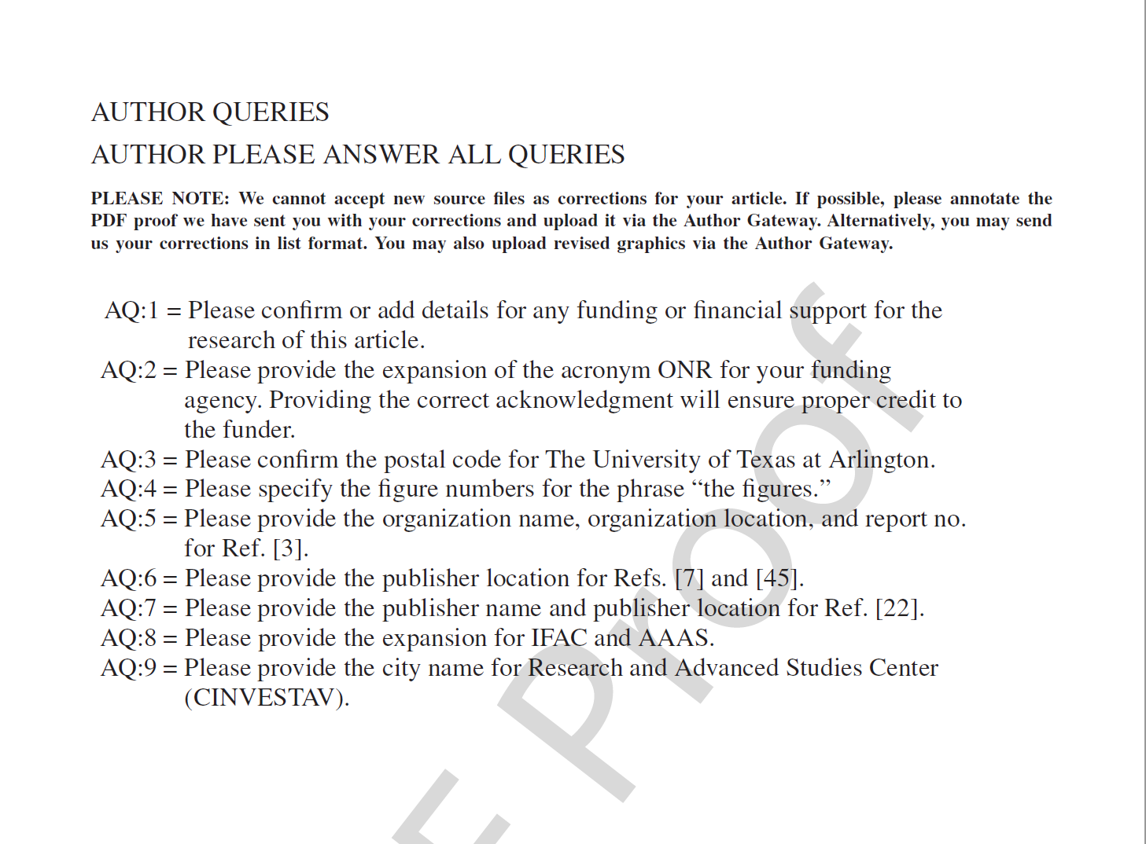

**Then you should**

1. **Answer the queries in a new word file, and label the changes in the manuscript pdf file.**
2. **Answer the queries**

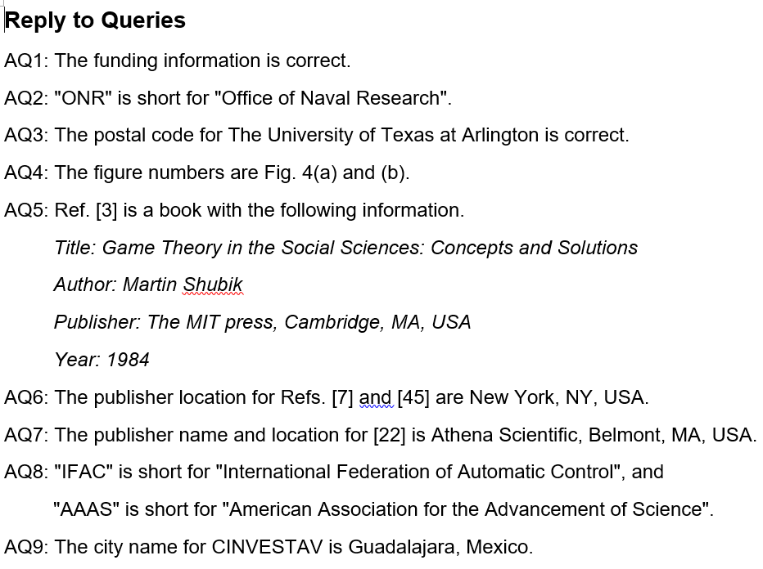

1. **Label the changes in the manuscript pdf file**

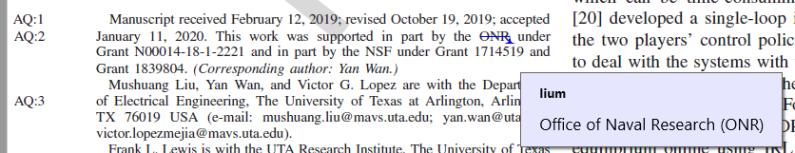

1. **Label other corrections you want to make, in both word and pdf files.**
2. **In word file:**

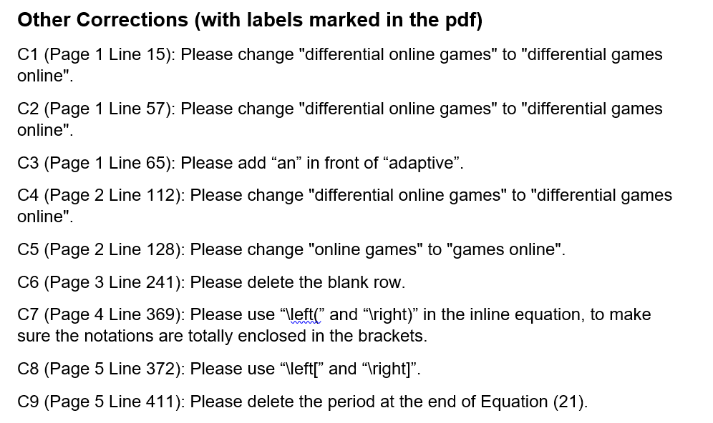

1. **In manuscript pdf file:**

